**Cline center calculation and plot**

To convert Cline center information into coordinate information based on transect coordinates and Cline center distance. **Distance, initial bearing between transects and destination points of low and high cline centers** were calculated at https://www.movable-type.co.uk/scripts/latlong.html, or to apply the package of this website mentioned above.

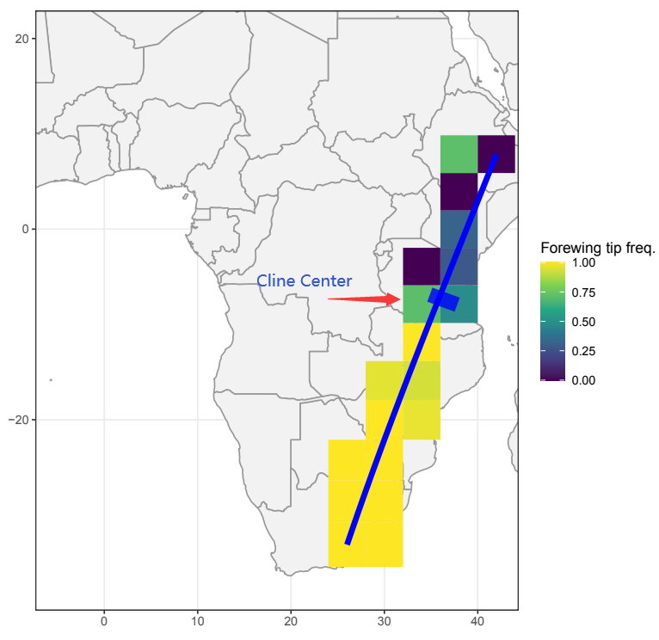

**Calculation example:**

1. **Input data** from [Table S1 Best Cline Models selection and basic parameters for Danaus chrysippus2](https://docs.google.com/spreadsheets/d/1eIf0T4DldFraDS_cpbWHYHnlXqgr5RPz/edit?usp=sharing&ouid=117236003263038849821&rtpof=true&sd=true).

Transect 1 in Central Africa with **start and end coordinates** information.

lon_start (-14) W

lat_start 16 N

lon_end 38 E

lat_end (-8) S

1. **Distance and initial bearing calculation**

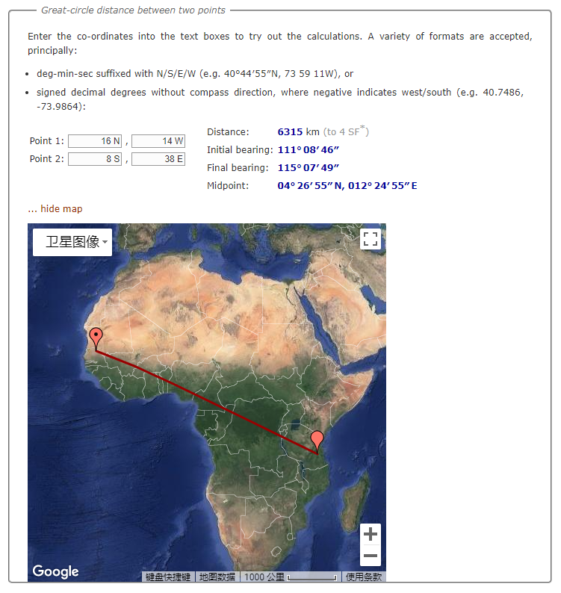

You got Distance of the transect equal to 6315 km and Initial bearing(angle) 111° 08′ 46″.

1. **Second input file** from cline analysis, you got lowest and highest cline center distance from Hindwing Transect 1 best cline model result. Distance information on **center2LLLow (km) and center2LLHigh (km)** refer to distance between start point of transect and “cline center start point” and “cline center end point”. Data source: [Table S1 Best Cline Models selection and basic parameters for Danaus chrysippus2](https://docs.google.com/spreadsheets/d/1eIf0T4DldFraDS_cpbWHYHnlXqgr5RPz/edit?usp=sharing&ouid=117236003263038849821&rtpof=true&sd=true).

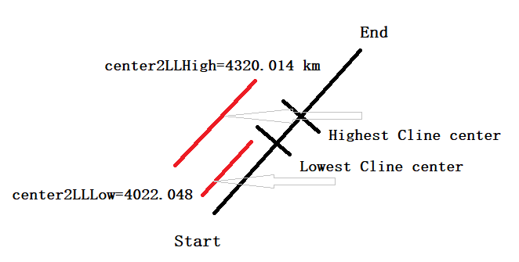

1. **Destination point calculation of Cline center (center2LLLow (km) and center2LLHigh (km) )**

Input data on Start point of transect, initial bearing and center2LLLow (km) distance, then you got coordinate of Destination point.

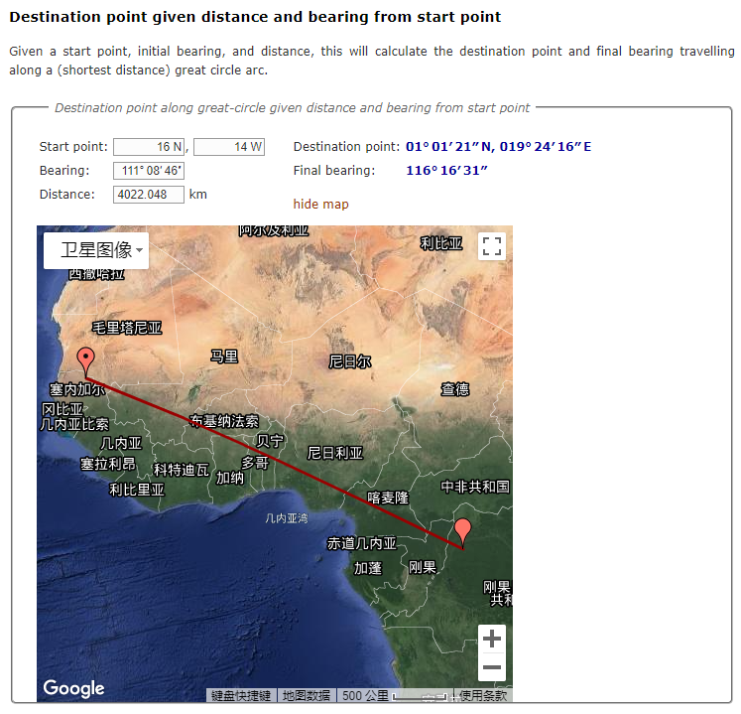

1. **Coordinates convert** from **01° 01′ 21″ N, 019° 24′ 16″ E** to 1.0225, 19.404444444444444.
2. **Destination points** information will be applied for **transect plot** script by adding “annotation” parameter to ggplot. <https://drive.google.com/drive/folders/12h1Ngfr5lzmyaI8eg78S8_lQhY73_cUf?usp=sharing>

# Transect 1 is central Africa and involves hindwing and forewing

i=1

trait <- records_4deg_transects[[i]]$hindwingWhite_a

n <- cap(records_4deg_transects[[i]]$hindwingWhite_n, 12)

trait_name <- "Hindwing white freq."

plot_map + Central_Africa +

geom_tile(data = records_4deg_transects[[i]],

aes(x = block_midpoint_long, y = block_midpoint_lat, fill = trait), inherit.aes = FALSE) +

scale_fill_viridis_c() + labs(fill = trait_name) +

annotate(geom="segment", x=transects$lon_start[i], xend=transects$lon_end[i],

y=transects$lat_start[i], yend=transects$lat_end[i], colour = transect_col, size=2) +

annotate(geom="segment", x=19.404444444444444, xend=21.806944444444444,

y=1.0225, yend=-0.164166666666666, colour = "Blue", size=10, alpha=0.8) ## add coordinate of both ends of cline center interval